Life

Presentation
Woman: Have you got your ticket?
Man: Yes, I have.
Woman: And your credit card?
Man: Yes, of course.
Woman: And your mobile?
Man: Yes, yes, I’ve got my mobile and I’ve got my keys and …
Woman: What about your passport?
Man: Oh, no!

Use possessive adjectives to talk about objects, people and places.
Subject pronouns | Possesive adjectives
I | my
you | your
he | his
she | her
it | its
we | our
they | their

I’ve got my ticket.
Have you got your passport?
His parents are Italian.
Her father’s from Argentina.
Venice is famous for its canals.
Our camera’s a Nikon.
Their daughter’s a doctor.

A possessive adjective has got one form for singular and plural: his brother, his parents.
Key vocabulary Everyday objects: credit card, glasses, laptop, mobile (= mobile phone), passport, ticket
Adjectives: awful, brilliant, fantastic, great, terrible
People in your life: mother, father, parents, son, daughter, children, husband, wife, brother, sister

- Write sentences.
- I’ve got a Nikon camera. It’s fantastic!

My camera’s fantastic!

- She’s got a new motorbike. It’s great!
- He’s got a Dell laptop. It’s brilliant!
- We’ve got an old car. It’s terrible!
- They’ve got an old television. It’s awful!

- Complete the text with his, her, their or its. Then listen and check.
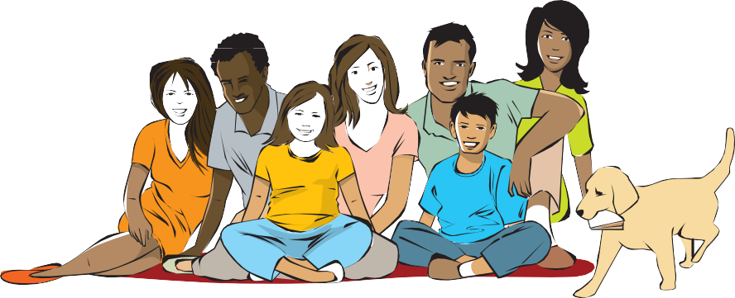
Ana’s Argentinian but 1 husband, Jacob, isn’t from Argentina. 2 father’s Nigerian and 3 mother’s Scottish. Ana’s got a sister and a brother. 4 sister’s a teacher and 5 brother’s a doctor. He’s married. 6 wife’s Italian. They’ve got two children: a son and a daughter. 7 daughter’s ten and 8 son’s six. They’ve also got a dog. 9 name is Rex.
- Choose the correct words.

  - Jane hasn’t got she / her passport.
  - We / Our new motorbike is fantastic.
  - She / Her is a doctor.
  - I / My haven’t got a fast car.
  - Where are you / your glasses?
  - He / His father is from the USA.
  - What’s it’s / its name?
  - They / Their son has got an apartment opposite the park.
  - Have you got I / my phone?
  - We / Our have got a house near here.
  - He / His mobile is on the table.
  - I / My mother is from Madrid.

Elementary Unit 1b
Exercises
5 Complete the sentences about a friend. Use the words in brackets.
- My friend has got two sisters. Their names are Clare and Penny. (brothers/sisters) My friend (brothers/sisters)
- He/She (married/single)
- He/She (children/dog)
- He/She (car/bike)

