WORKSHOP: Listening and Reading

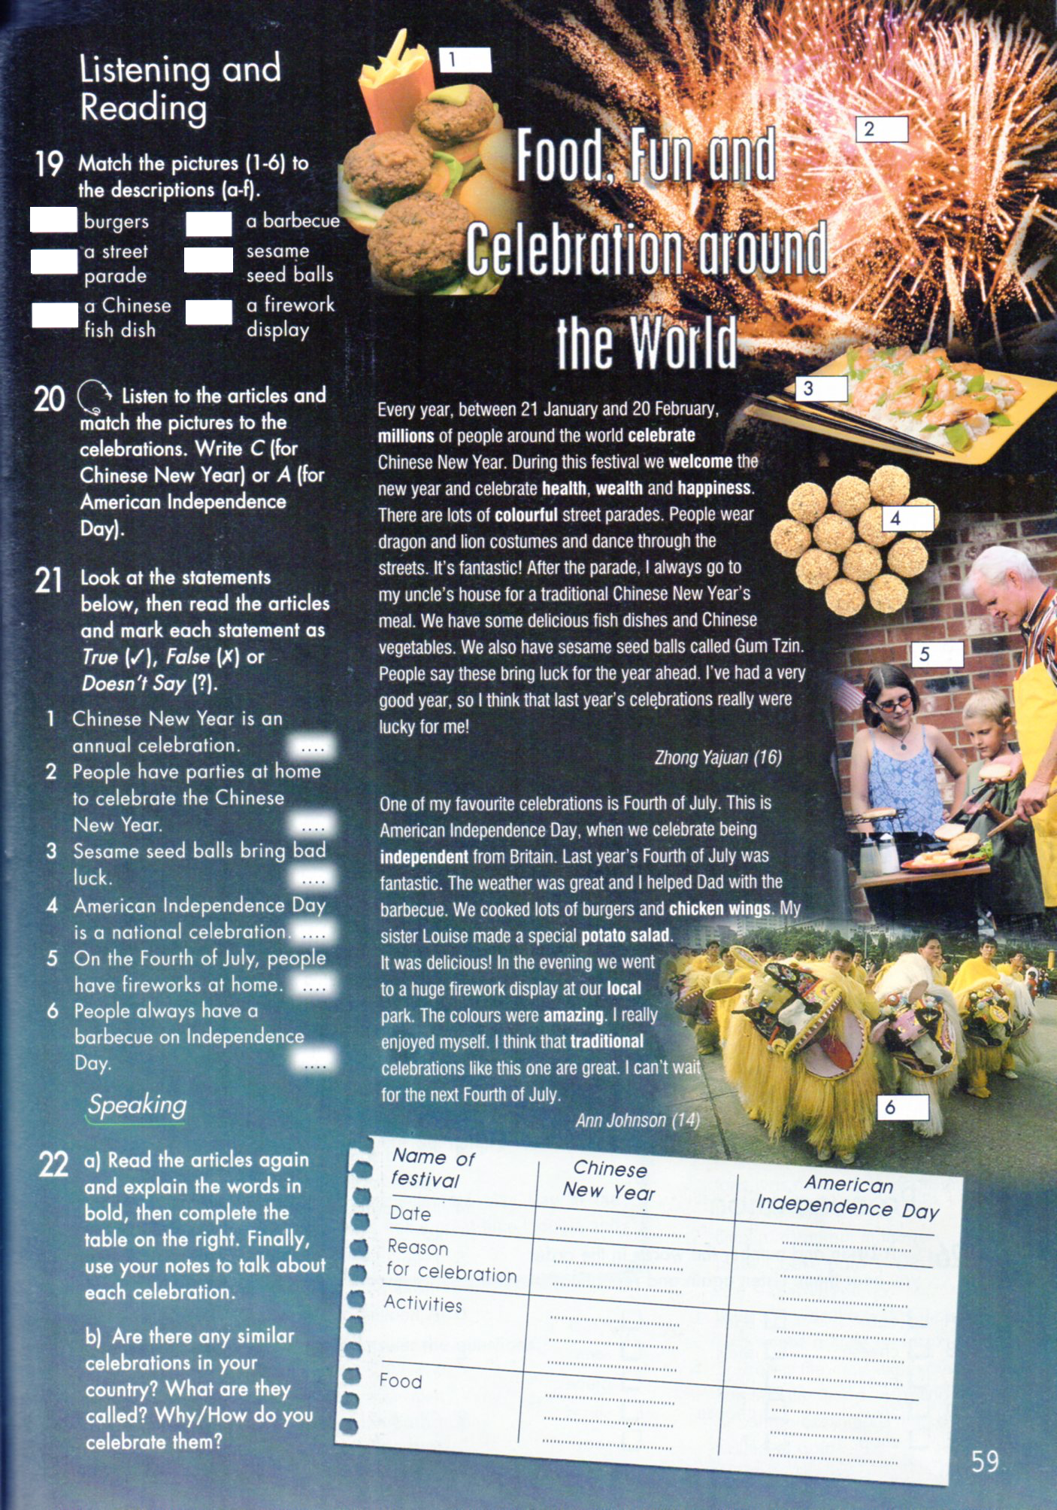

Now students make a poster, for that purpose you do some research about the following aspects:

Choose a country of your preference and think of an annual festival and answer these questions to make it.

- Name of the country, capital, language.
- Include the flag
- Which are the neighbors of the chosen country?
- Symbols
- What is the name of the festival?
- When does it take place?
- Where does it take place?
- What is the reason for the festival?
- What are the preparations to celebrate it, what actions people use to do to make it possible? Think about: national dish, costumes, decorations, parades etc.
- What happens during the festival?
11.Recommend the festival to your audience.

